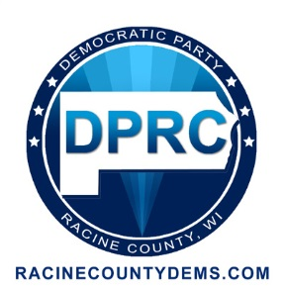
Democratic Party of Racine County
2014 Awards Banquet “Forward In Unity”
Sunday, April 27
Sunday, April 27, 2014 Infusino’s Banquet Hall
4:00 p.m. Cocktail Hour 3201 Rapids Drive
5:00 p.m. Dinner Racine, Wisconsin
PLEASE RSVP BY APRIL 15
TICKETS: $35.00/ $25.00 Students
AFTER APRIL 15: $40.00/$30.00 Students
Tables of 8 Available

Please reserve a table for 8. Print names of guests below.

I cannot attend by would like to donate $

Please list my name as a sponsor in the program for $10.00.

# of Tickets Total Amount Enclosed $

Telephone Email

Please mail payment to DPRC, Box 081825, Racine WI 53408

