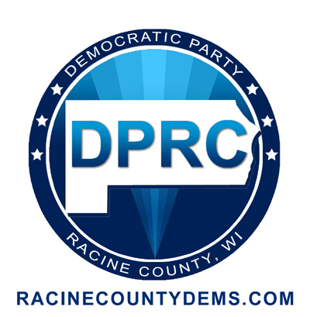
Democratic Party of Racine County
2014 Awards Banquet “Forward In Unity”
Advertise in the Program Booklet
Name/Organization
Contact Person Phone
Mailing Address
*Insert my name as a sponsor $10.00
*Business Card $30.00
*Quarter Page (2 x 3 ¼) $50.00
*Half Page (4 ½ x 3 ½) $75.00
*Full Page $100.00
Ad Deadline April 8
Form and payment must be received by April 8 to appear in program.
Please enclose a copy of your ad or email file to janewitt@tds.net

Please make payment and mail to
DPRC, PO Box 081825, Racine WI 53408

